./

GENESIS – Learning Report and Mini Project Report



|  |  |  |  |  |  |
| --- | --- | --- | --- | --- | --- |
| **Ver. Rel. No.** | **Release Date** | **Prepared. By** | **Reviewed By** | **To be Approved** | **Remarks/Revision Details** |
| V1.1 | 27/12/2020 | Shriram M S |  | Sreenivas K |  |
|  |  |  |  |  |  |
|  |  |  |  |  |  |
|  |  |  |  |  |  |
|  |  |  |  |  |  |

**Details**

Contents

List Of Figures 5

List Of Tables 5

1 MINIPROJECT 1 – Scientific Calculator 5

1.1 Module 5

1.2 Requirements 5

1.2.1 State of the art - Aging & Costing 5

1.2.2 4W1H 5

1.2.3 High Level & Low Level Requirements 5

1.2.4 SWOT Analysis 6

1.3 Design 6

1.3.1 Structural Diagram 6

1.3.2 Behavioral Diagrams 6

1.4 Test Plan 6

1.5 Implementation Summary 6

1.5.1 Video Summary 6

1.5.2 Git Link 6

1.5.3 Git Dashboard 6

1.5.4 Summary 6

1.6 Individual Contribution and Highlights 6

1.6.1 Summary 6

1.6.2 Challenges faced and how they were overcome 6

2 MINIPROJECT 2 - Stadium Ticket Reservation System 6

2.1 Module 6

2.2 Requirements 6

2.2.1 State of the art - Aging & Costing 7

2.2.2 4W1H 7

2.2.3 High Level & Low Level Requirements 7

2.2.4 SWOT Analysis 8

2.3 Design [1] 9

2.3.1 Structural Diagram 9

2.3.2 Behavioral Diagrams 11

2.4 Test Plan 11

2.5 Implementation Summary 13

2.5.1 Video Summary 13

2.5.2 Git Link 13

2.5.3 Git Dashboard 13

13

2.5.4 Summary 13

2.6 Individual Contribution and Highlights 13

2.6.1 Summary 13

2.6.2 Challenges faced and how they were overcome 13

3 MINIPROJECT 3 – Temperature Monitoring System 14

3.1 Module 14

3.2 Requirements 14

3.2.1 State of the art - Aging & Costing 14

3.2.2 4W1H 14

3.2.3 High Level & Low Level Requirements 14

3.2.4 SWOT Analysis 14

3.3 Design 14

3.3.1 Structural Diagram 14

3.3.2 Behavioral Diagrams 14

3.4 Test Plan 14

3.5 Implementation Summary 14

3.5.1 Video Summary 14

3.5.2 Git Link 14

3.5.3 Git Dashboard 14

3.5.4 Summary 14

3.6 Individual Contribution and Highlights 15

3.6.1 Summary 15

3.6.2 Challenges faced and how they were overcome 15

4 References 15

# List Of Figures

*Figure 1 : Miniproject 1 - Component Diagram* 8

*Figure 2 : Miniproject 1 - Activity Diagram* 9

*Figure 3 : Miniproject 1 - Trigonometric Activity Diagram* 9

*Figure 4 : Miniproject 1 - Dashboard* 11

*Figure 5 : Miniproject 2 - Class Diagram* 17

*Figure 6 : Miniproject 2 - Activity Diagram* 18

*Figure 7 : Miniproject 2 - Dashboard* 20

*Figure 8 : Miniproject 3 - Use Case Diagram* 24

*Figure 9 : Miniproject 3 - Activity Diagram* 25

*Figure 10 : Miniproject 3 - Dashboard* 27

# List Of Tables

*Table 1 : Miniproject 1 - 4W1H* 6

*Table 2 : Miniproject 1 - High Level Requirements* 6

*Table 3 : Miniproject 1 - Low Level Requirements* 7

*Table 4 : Miniproject 1 - Test Cases* 10

*Table 5 : Miniproject 1 - Individual Contributions* 12

*Table 6 : Miniproject 2 - 4W1H* 14

*Table 7 : Miniproject 2 - High Level Requirements* 14

*Table 8 : Miniproject 2 - Low Level Requirements* 15

*Table 9 : Miniproject 2 - Test Cases* 19

*Table 10 : Miniproject 2 - Individual Contribution* 21

*Table 11 : Miniproject 3 - 4W1H* 23

*Table 12 : Miniproject 3 - High Level Requirements* 23

*Table 13 : Miniproject 3 - Low Level Requirements* 23

*Table 14 : Miniproject 3 - Test Cases* 26

*Table 15 : Miniproject 3 - Individual Contributions* 28

# List Of Abbreviations

1. HL - High Level
2. LL - Low Level

# MINIPROJECT 1 – Scientific Calculator

## Module

* Applied SDLC and Software Testing

## Requirements

### State of the art - Aging & Costing

A scientific calculator is a type of electronic calculator, usually but not always handheld, designed to calculate problems in science, engineering, and mathematics. They have completely replaced slide rules in traditional applications, and are widely used in both education and professional settings.

Computation has come a long way, from analogous methods to perform complex operations to instant results just by the push of a few buttons. Expenditure for such a device is nominal and is worth the money.

### 4W1H

|  |  |
| --- | --- |
| **What** | Simple scientific calculator able to perform variety of operations. |
| **Where** | This was implemented using c programming language in VS Code. |
| **When** | This project once build can be utilized throughout its run time to compute any of the complex operations. |
| **Why** | Scientific calculators are used widely in situations that require quick access to certain mathematical functions, especially those that were once looked up in mathematical tables, such as trigonometric functions or logarithms. |
| **How** | User can choose from the menu option what sort of an operation they would like to perform. According to the operation chosen, provide input and the result will be displayed instantly. |

*Table 1 : Miniproject 1 - 4W1H*

### High Level & Low Level Requirements

#### High Level Requirements

|  |  |
| --- | --- |
| **REQUIREMENT ID** | **DESCRIPTION** |
| HL_01 | Navigation bar containing Menu |
| HL_02 | Arithmetic |
| HL_03 | Trigonometric |
| HL_04 | Logarithmic, Exponential & Probabilistic functions |

*Table 2 : Miniproject 1 - High Level Requirements*

#### Low Level Requirements

|  |  |
| --- | --- |
| **REQUIREMENT ID** | **DESCRIPTION** |
| LL_01 | A menu containing arithmetic, trigonometric, logarithmic, probability functions, exponential functions & other functions |
| LL_02 | Addition |
| LL_03 | Multiplication |
| LL_04 | Subtraction |
| LL_05 | Division |
| LL_06 | Remainder |
| LL_07 | Sinusoidal |
| LL_08 | Cosine |
| LL_09 | Tangential |
| LL_10 | Sin Inverse |
| LL_11 | Cosine Inverse |
| LL_12 | Tan Inverse |
| LL_13 | Decimal Logarithm |
| LL_14 | Power operation |
| LL_15 | Natural Logarithm |
| LL_16 | Exponent |
| LL_17 | Variance |
| LL_18 | Standard deviation |
| LL_19 | Square root |
| LL_20 | Mean |

*Table 3 : Miniproject 1 - Low Level Requirements*

### SWOT Analysis

#### Strength

* Simple.
* User friendly.
* Long lasting and most of the scientific functions.

#### Weakness

* Can’t handle the exceptional cases like boundary overflow and division by zero.
* Floating point operations are absent.

#### Opportunity

* Can integrate more complex operations into this and improve features.
* Can integrate floating point operations.

#### Threats

* Imaginary values cannot be displayed.

## Design

### Structural Diagram

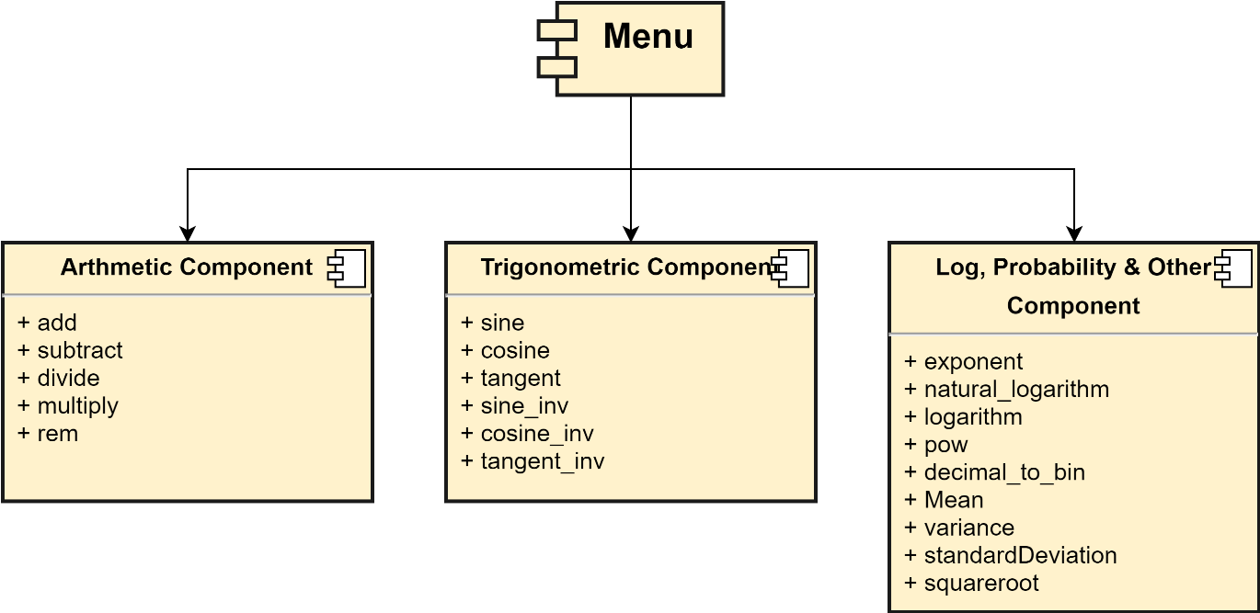

*Figure 1 : Miniproject 1 - Component Diagram*

### Behavioral Diagrams

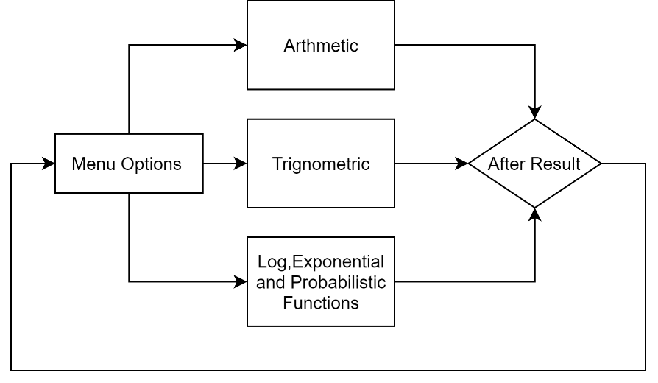

*Figure 2 : Miniproject 1 - Activity Diagram*

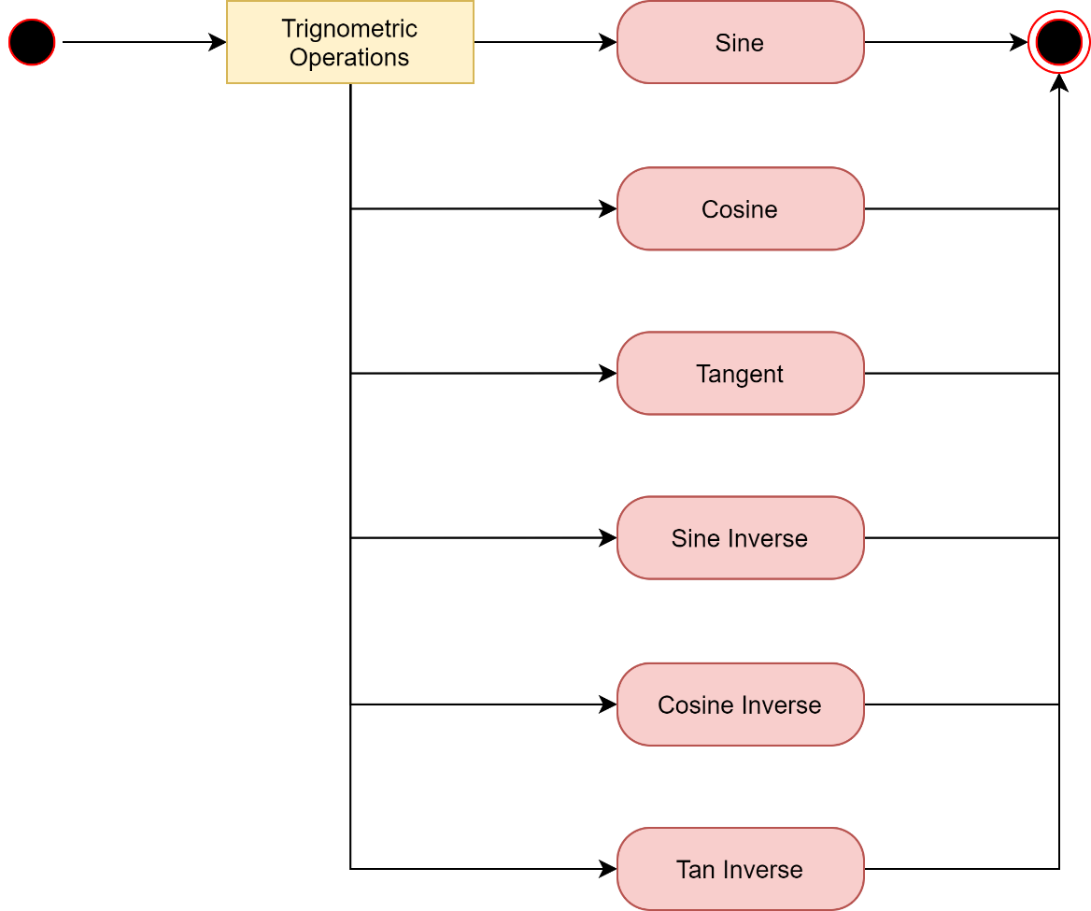

*Figure 3 : Miniproject 1 - Trigonometric Activity Diagram*

## Test Plan

|  |  |  |  |  |  |
| --- | --- | --- | --- | --- | --- |
| **Test Case ID** | **Req. ID Mapping** | **Test Scenario** | **Test Steps** | **Test Data** | **Expected Result** |
| HL_T_01 | HL_01 | Navigation bar containing menu | 1. Open program | Value = 1/2/3 | Successful navigation |
| HL_T_02 | HL_02 | Arithmetic | 1. Select 1st menu option | Value = 1 | Arithmetic operations displayed |
| HL_T_03 | HL_03 | Trigonometric | 1. Select 2nd menu option | Value = 2 | Trigonometric operations displayed |
| HL_T_04 | HL_04 | Logarithmic functions, Probability functions & Other functions | 1. Select 3rd menu option | Value = 3 | Other operations displayed |
| LL_T_01 | LL_01 | Addition | 1. Enter values | Value = 2,3 | 5 |
| LL_T_02 | LL_02 | Subtraction | 1. Enter values | Value = 8,3 | 5 |
| LL_T_03 | LL_03 | multiplication | 1. Enter values | Value = 2,3 | 6 |
| LL_T_04 | LL_04 | Division | 1. Enter values | Value = 15,3 | 5 |
| LL_T_05 | LL_05 | sine | 1. Enter values | Value = 30 | 0.500000 |
| LL_T_06 | LL_06 | cosine | 1. Enter values | Value = 60 | 0.500000 |
| LL_T_08 | LL_08 | Tan | 1. Enter values | Value = 30 | -5.405001 |
| LL_T_09 | LL_09 | Addition | 1. Enter values | Value = 0.5 | 5 |
| LL_T_10 | LL_10 | Cosine Inv | 1. Enter values | Value = 0.5 | 60.00000 |
| LL_T_11 | LL_11 | Tan Inverse | 1. Enter values | Value = 1 | 45.00000 |
| LL_T_12 | LL_12 | exponent | 1. Enter values | Value = 0.5 | 148.413162 |
| LL_T_13 | LL_13 | Natural log | 1. Enter values | Value = 5 | 1.609438 |
| LL_T_14 | LL_14 | logarithm | 1. Enter values | Value = 5 | 0.698970 |
| LL_T_15 | LL_15 | Square root | 1. Enter values | Value = 5 | 2.236068 |
| LL_T_16 | LL_16 | power | 1. Enter values | Value = 5,2 | 25 |
| LL_T_17 | LL_17 | mean | 1. Enter values | Value = [2,6],2 | 4 |
| LL_T_18 | LL_18 | Variance | 1. Enter values | Value = [2,6],2 | 4.00000 |
| LL_T_19 | LL_19 | Standard deviation | 1. Enter values | Value = 4 | 2.00000 |

*Table 4 : Miniproject 1 - Test Cases*

## Implementation Summary

### Video Summary

### Git Link

* [99003173/Scientific-Calculator (github.com)](https://github.com/99003173/Scientific-Calculator)

### Git Dashboard

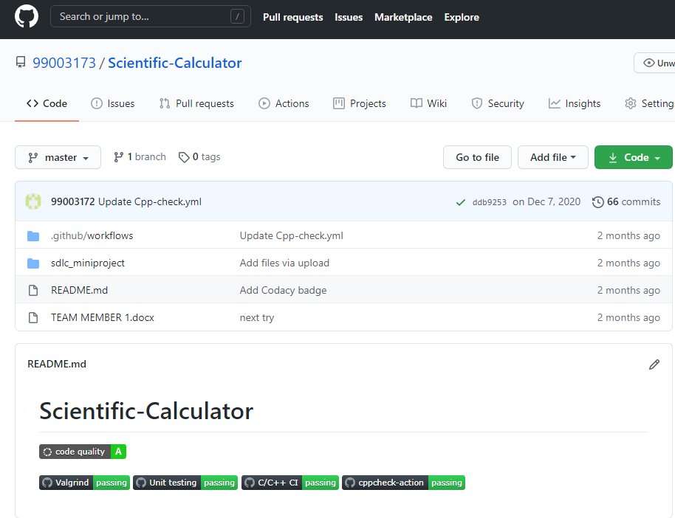

*Figure 4 : Miniproject 1 - Dashboard*

### Summary

## Individual Contribution and Highlights

### Summary

|  |  |  |  |  |
| --- | --- | --- | --- | --- |
| **Team Members**  **(PS Number)** | **Lines of Code** | **No. of Functions** | **No. of Test Cases** | **Status** |
| M Reethu (99003171) | 66 | 6 | 6 | Passed |
| Hareesh unnikrishnan (99003172) | 76 | 7 | 7 | Passed |
| Shriram M S (99003173) | 79 | 7 | 7 | Passed |

*Table 5 : Miniproject 1 - Individual Contributions*

### Challenges faced and how they were overcome

* Had difficulty in linking GitHub account to VSCode, but with support from Alen V George, I could overcome this problem.
* Had trouble in float datatype testing but my teammate Hareesh helped me understand it.
* Faced difficulty with test cases during build but got to understand and overcome this.

# MINIPROJECT 2 - Stadium Ticket Reservation System

## Module

* Advanced Python Programming and Testing

## Requirements

### State of the art - Aging & Costing

Standing in long queues just to get a glimpse of a thrilling match was something that existed 5 years ago. Nowadays, stadium ticket reservations have been made so much better by advancement in web-based applications and mobile applications that allow any legal citizen to purchase tickets by online transaction methods (Net banking, UPI).

In this project, we have built a stadium ticket reservation system for matches that is being held all over the country. From here, people can choose a stadium location and a corresponding match being held on that location, and then book tickets for any ‘n’ numbers.

Since all functions are online, you do not require any funding or expenditure to set up such a system.

### 4W1H

|  |  |
| --- | --- |
| **What** | This is a stadium ticket reservation system built to allow legal citizens to purchase tickets for any sporting event. |
| **Where** | This project is used on an online platform. |
| **When** | The tickets can be purchased a few days before a scheduled match. |
| **Why** | This project helps customers to book tickets with ease and the organizers can easily keep track of tickets being booked by maintaining a database. |
| **How** | Users can select a desired stadium location and match to book tickets. Next, the user can book tickets and see seat availabilities pertaining to that match. |

*Table 6 : Miniproject 2 - 4W1H*

### High Level & Low Level Requirements

#### High Level Requirements

|  |  |
| --- | --- |
| **REQUIREMENT ID** | **DESCRIPTION** |
| HL_01 | View match schedule by collecting data from input file. |
| HL_02 | View total cost after booking completes. |
| HL_03 | View seat availability for a particular match after booking completes. |
| HL_04 | User can exit from the menu screen. |
| HL_05 | Ticket count shall be displayed after every booking. |
| HL_06 | Provide unique reference number for every booking made. |

*Table 7 : Miniproject 2 - High Level Requirements*

#### Low Level Requirements

|  |  |
| --- | --- |
| **REQUIREMENT ID** | **DESCRIPTION** |
| LL_01 | Shall be able to select required location. |
| LL_02 | Shall be able to select a scheduled match. |
| LL_03 | Shall be able to view current seating details prior to booking. |
| LL_04 | Shall be able to provide username. |
| LL_05 | Shall be able to generate reference number. |
| LL_06 | Shall be able to book any desired ticket count during an ongoing booking. |
| LL_07 | Shall be able to see full booking details after booking. |
| LL_08 | Shall be able to view current seating details after booking. |

*Table 8 : Miniproject 2 - Low Level Requirements*

### SWOT Analysis

#### Strength

* Keep track of tickets booked.
* Maintain clear records of individual bookings.
* Easy to navigate and book tickets.
* Match schedule details can be easily updated.

#### Weakness

* Password authentication could be added.
* Detail of only the user who books the ticket is collected, and not of the other members accompanying him/her (if any).
* Seating is not separated based on tiers and stands.

#### Opportunity

* Can include gallery, 1st tier, 2nd tier, VIP seating arrangements at different rates.
* Can include ticket booking facilities according to different sporting events happening at the same stadium.

#### Threats

* Users need to be ensured that booking tickets via online platforms are safe and secure.
* Authentication need to be made much more strong and secure.

## Design [1]

### Structural Diagram

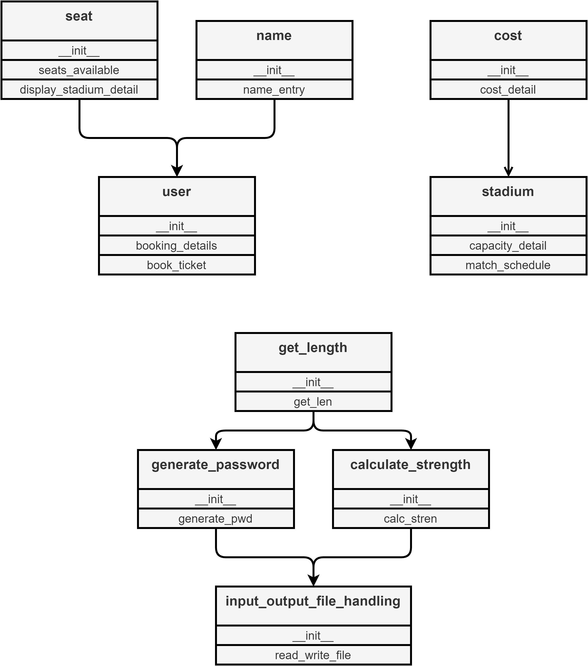

*Figure 5 : Miniproject 2 - Class Diagram*

### Behavioral Diagrams

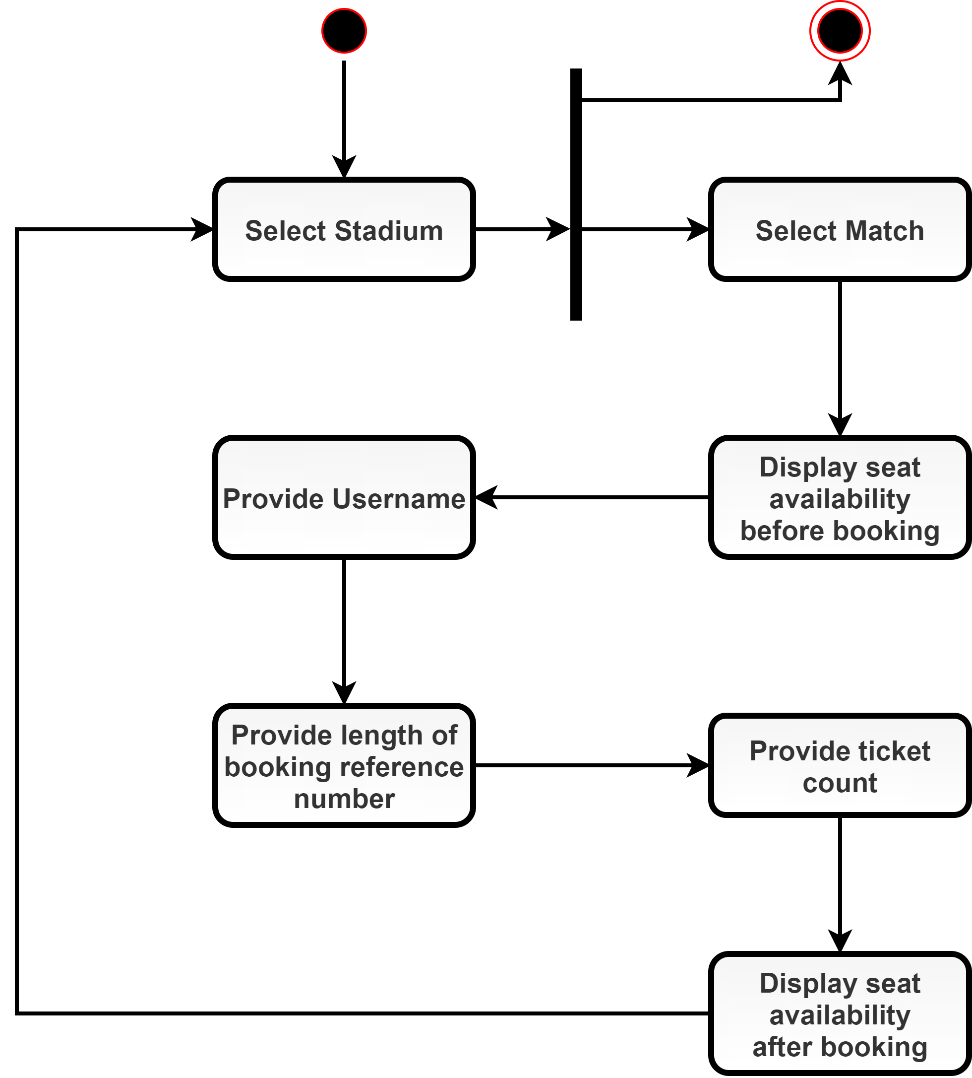

*Figure 6 : Miniproject 2 - Activity Diagram*

## Test Plan

|  |  |  |  |  |
| --- | --- | --- | --- | --- |
| **Test Case ID** | **Test Scenario** | **Test Steps** | **Test Data** | **Expected Result** |
| LL_T01 | Check whether locations are chosen correctly | 1. Select first location | Value = 1 | Mumbai |
| LL_T02 | Check whether locations are chosen correctly | 1. Select second location | Value = 2 | Kolkata |
| LL_T03 | Check whether locations are chosen correctly | 1. Select third location | Value = 3 | Chennai |
| LL_T04 | Check whether exit can be selected | 1. Select any characters other than those in menu | Value = 0 | Program exit |
| HL_T05 | Check whether matches are chosen correctly | 1. Select first scheduled match | Value = 1 | Proceed to booking for first match |
| HL_T06 | Check whether matches are chosen correctly | 1. Select second scheduled match | Value = 2 | Proceed to booking for second match |
| HL_T07 | Check whether matches are chosen correctly | 1. Select third scheduled match | Value = 3 | Proceed to booking for third match |
| HL_T08 | Check whether arbitrary length for reference number could be inserted | 1. Pass any arbitrary length | Value = 13 | Random reference code of length 13 |
| HL_T09 | Check whether strength is displayed along with reference code | 1. Pass any arbitrary length | Value = 9 | Low/  Medium/  Strong |
| HL_T10 | Check whether seat count can be inserted | 1. Pass any arbitrary seat count | Value = 4 | 4 tickets are booked |
| HL_T11 | Check whether upon selection of seats, tickets are generated | 1. Pass any arbitrary seat count | Value = 6 | Username, Stadium,  Match, Tickets, Total cost, Booking date  are displayed |
| HL_T12 | Check whether the booking reflects on the final seat availability | 1. Pass any arbitrary seat count |  |  |

*Table 9 : Miniproject 2 - Test Cases*

## Implementation Summary

### Video Summary

### Git Link

* [99003169/PythonMiniProject (github.com)](https://github.com/99003169/PythonMiniProject)

### Git Dashboard

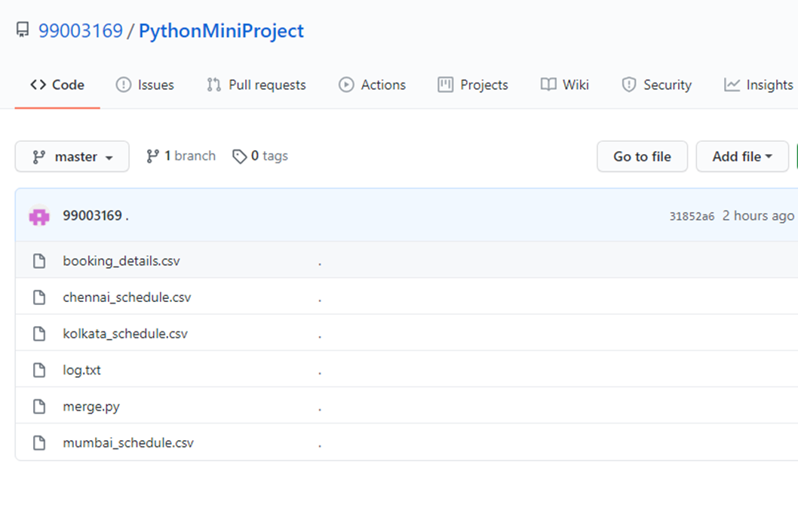

*Figure 7 : Miniproject 2 - Dashboard*

## Individual Contribution and Highlights

### Summary

|  |  |  |  |  |
| --- | --- | --- | --- | --- |
| **PS No.** | **Lines of Code** | **No. of Functions** | **No. of Test Cases** | **Status** |
| 99003173 | 182 | 12 | 6 | Passed |
| 99003169 | 150 | 10 | 6 | Passed |

*Table 10 : Miniproject 2 - Individual Contributions*

### Challenges faced and how they were overcome

* Had ***difficulty*** in utilizing the .csv files for input output operations, but the team ***overcame*** this by doing a lot of research.

# MINIPROJECT 3 – Temperature Monitoring System

## Module

* Embedded C

## Requirements

### State of the art - Aging & Costing

A few decades ago, when the world was still “analog”, it was difficult for a person to precisely read temperature value by trying to read from a thermometer. But now the world has changed, temperature is easily sensed by digital devices and converted into an easy format for human to read.

In our project, we have utilized an STM32F board discovery board to read temperature via a DHT11 temperature and humidity sensor, and then interface it to an Arduino Uno board to check an ambient temperature condition by checking whether the green LED toggles or the red LED toggles.

Cost for setting up this depends on the rate of the boards and sensors utilized.

### 4W1H

|  |  |
| --- | --- |
| **What** | An embedded C project to sense temperature and display whether it is an ambient value. |
| **Where** | This project is implemented on STM32F discovery board serially interfaced with an Arduino Uno with help of a DHT11 sensor. |
| **When** | This project once setup can be used continuously as long there is power supplies to the 2 boards. |
| **Why** | This project helps people to be able to visually see whether an ambient temperature is present in the room. |
| **How** | The sensor sends the temperature value through SPI interface to the Arduino Uno board from the STM32F board and the value is monitored there. The green LED in STM32F toggles if room temperature is ambient, else red LED toggles. |

*Table 11 : Miniproject 3 - 4W1H*

### High Level & Low Level Requirements

#### High Level Requirements

|  |  |
| --- | --- |
| **REQUIREMENT ID** | **DESCRIPTION** |
| HL_01 | Temperature goes below the lower threshold value |
| HL_02 | Shall sense temperature |
| HL_03 | Temperature goes above the upper threshold value |
| HL_04 | Stable communication shall exist between the 2 boards |

*Table 12 : Miniproject 3 - High Level Requirements*

#### Low Level Requirements

|  |  |
| --- | --- |
| **REQUIREMENT ID** | **DESCRIPTION** |
| LL_01 | MCU Specific header file is present |
| LL_02 | STM32F discovery board shall be used |
| LL_03 | Arduino Uno board shall be used |
| LL_04 | DHT11 sensor shall be used |
| LL_05 |  |
| LL_06 |  |
| LL_07 |  |
| LL_08 |  |

*Table 13 : Miniproject 3 - Low Level Requirements*

### SWOT Analysis

#### Strength

#### Weakness

#### Opportunity

#### Threats

## Design

### Structural Diagram

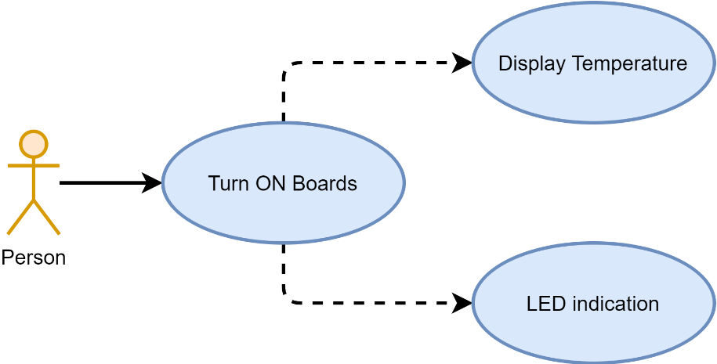

*Figure 8 : Miniproject 3 - Use Case Diagram*

### Behavioral Diagrams

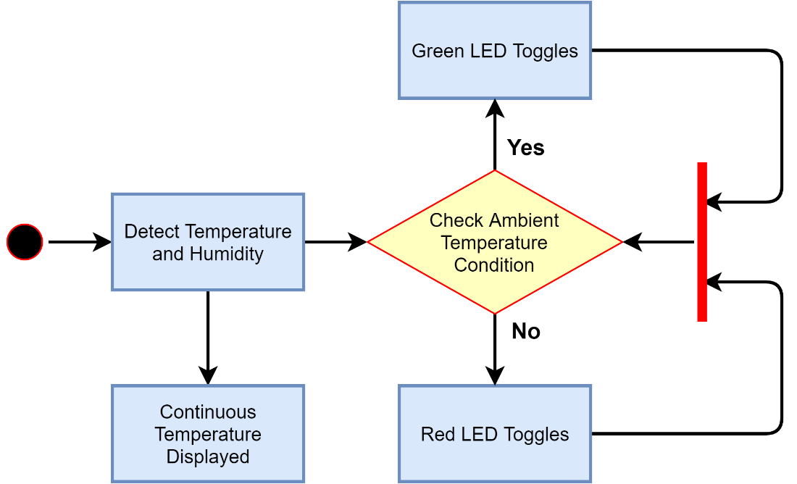

*Figure 9 : Miniproject 3 - Activity Diagram*

## Test Plan

|  |  |  |  |  |
| --- | --- | --- | --- | --- |
| **Test Case ID** | **Test Scenario** | **Test Steps** | **Test Data** | **Expected Result** |
| LL_T_01 | Check whether locations are chosen correctly |  | Value = 1 |  |
| LL_T_02 | Check whether locations are chosen correctly |  | Value = 2 |  |
| LL_T_03 | Check whether locations are chosen correctly |  | Value = 3 |  |
| LL_T_04 | Check whether exit can be selected |  | Value = 0 |  |
| HL_T_05 | Check whether matches are chosen correctly |  | Value = 1 |  |
| HL_T_06 | Check whether matches are chosen correctly |  | Value = 2 |  |
| HL_T_07 | Check whether matches are chosen correctly |  | Value = 3 |  |
| HL_T_08 | Check whether arbitrary length for reference number could be inserted |  | Value = 13 |  |
| HL_T_09 | Check whether strength is displayed along with reference code |  | Value = 9 |  |
| HL_T_10 | Check whether seat count can be inserted |  | Value = 4 |  |
| HL_T_11 | Check whether upon selection of seats, tickets are generated |  | Value = 6 |  |
| HL_T_12 | Check whether the booking reflects on the final seat availability |  |  |  |

*Table 14 : Miniproject 3 - Test Cases*

## Implementation Summary

### Video Summary

### Git Link

* [99003173/EMBEDDED_PROJECT (github.com)](https://github.com/99003173/EMBEDDED_PROJECT)

### Git Dashboard

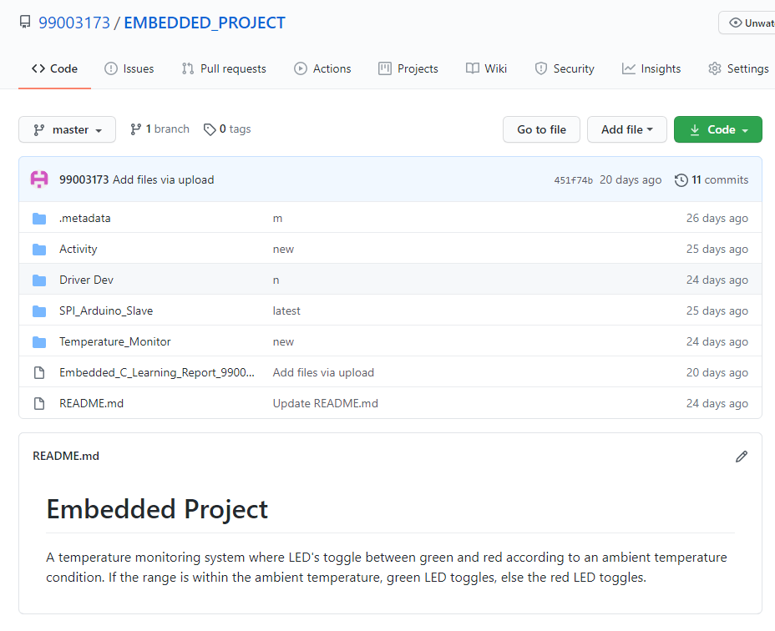

*Figure 10 : Miniproject 3 - Dashboard*

### Summary

## Individual Contribution and Highlights

### Summary

|  |  |  |  |  |
| --- | --- | --- | --- | --- |
| **PS Number** | **Lines of Code** | **No. of Functions** | **No. of Test Cases** | **Status** |
| 99003172 |  |  |  | Passed |
| 99003173 |  |  |  | Passed |

*Table 15 : Miniproject 3 - Individual Contributions*

### Challenges faced and how they were overcome

# References

**There are no sources in the current document.**